
2026 CAIRNS OPEN CHAMPIONSHIPS
State Ranking Event

EVENT DETAILS
Date: Saturday, 19 September 2026 to Sunday, 20 September
Location: Table Tennis Cairns, 99 Sheridan Street, Cairns QLD 4870
Referees: Brendan Gaeta / Peter Waddell / Rhonda Miller
Tournament Directors / Administrators: Paul Uttley and Daryl Sterling

ENTRY DETAILS
Entry Closure Date: Saturday, 12 September 2026
Email Entries: Daryl darylsterlingjr@gmail.com
Enquiries: Daryl Sterling – 0474 127 384

ALL INFORMATION BELOW MUST BE COMPLETED (YOU CAN ALSO ENTER ONLINE)
Full Name: | ……….………………...………………. |  | Men’s Open Singles & Women’s Open Singles: $300 for the winner & $150 for the runner-up (subject to a minimum of 18 entries)
DOB: | ……….………………...……………….
Email: | ……….………………...……………….
Phone: | ……….………………...……………….
Association: | ……….………………...……………….
National ID No: | ……….………………...………………. |  | Rating Central ID: …...……………
 |  |  | Rating: ………………...……………
By signing this Entry Form I acknowledge that I have read and understood the attached Event Conditions and I agree to be bound by the Event Conditions
Signature: …………………………….……………….…….
If under 18, name of parent/guardian:……………………………..………

All singles events (aged & rated) will be RR groups of 3 to KO (Players may advance directly to KO).
2 players will advance from age groups & 1 player will advance from rated group. All doubles are KO.
Players may enter 1 event per time slot
Players may enter a maximum of 3 consecutive age events, including their age event. The Referee may remove a player from a 3rd age event at the Referee’s discretion based on numbers and clashes.

Doubles Partner (you may insert ‘Required’)
# | Event | Partner
3 | Men’s Open Doubles | ……….……………….....................................
4 | Women’s Open Doubles | ……….……………….....................................
5 | Mixed Open Doubles | ……….……………….....................................
13 | Doubles Rating < 1500 | ……….……………….....................................
14 | Doubles Rating < 1300 | ……….……………….....................................
15 | Doubles Rating < 1100 | ……….……………….....................................
16 | Doubles Rating < 900 | ……….……………….....................................
EVENT LIST AND ENTRY FORM
# | Event | Cost  (pp) |  | # | Event | Cost  (pp)
1 | Men’s Open Singles | $17.00 |  | 23 | >65 Women’s Singles | $10.00
2 | Women’s Open Singles | $17.00 |  | 24 | >70 Men’s Singles | $10.00
3 | Men’s Open Doubles | $10.00 each |  | 25 | >70 Women’s Singles | $10.00
4 | Women’s Open Doubles | $10.00 each |  | 26 | >75 Men’s Singles | $10.00
5 | Mixed Open Doubles | $10.00 each |  | 27 | >75 Women’s Singles | $10.00
6 | Singles Rating < 1500 | $12.00 |  | 28 | >80 Men’s Singles | $10.00
7 | Singles Rating < 1300 | $12.00 |  | 29 | >80 Women’s Singles | $10.00
8 | Singles Rating < 1100 | $12.00 |  | 30 | <21 Boy’s Singles | $10.00
9 | Singles Rating < 900 | $12.00 |  | 31 | <21 Girl’s Singles | $10.00
10 | Doubles Rating < 1500 | $8.00 each |  | 32 | <19 Boy’s Singles | $9.00
11 | Doubles Rating < 1300 | $8.00 each |  | 33 | <19 Girl’s Singles | $9.00
12 | Doubles Rating < 1100 | $8.00 each |  | 34 | <17 Boy’s Singles | $9.00
13 | Doubles Rating < 900 | $8.00 each |  | 35 | <17 Girl’s Singles | $9.00
14 | >30 Men’s Singles | $10.00 |  | 36 | <15 Boy’s Singles | $9.00
15 | >30 Women’s Singles | $10.00 |  | 37 | <15 Girl’s Singles | $9.00
16 | >40 Men’s Singles | $10.00 |  | 38 | <13 Boy’s Singles | $8.00
17 | >40 Women’s Singles | $10.00 |  | 39 | <13 Girl’s Singles | $8.00
18 | >50 Men’s Singles | $10.00 |  | 40 | <11 Boy’s Singles | $8.00
19 | >50 Women’s Singles | $10.00 |  | 41 | <11 Girl’s Singles | $8.00
20 | >60 Men’s Singles | $10.00 |  | 42 | Para Singles | $10.00
21 | >60 Women’s Singles | $10.00 |  |  | TTQ Player Levy | $5.00
22 | >65 Men’s Singles | $10.00 |  | Total |  | $...........................


MAJOR
TOURNAMENT
SPONSOR

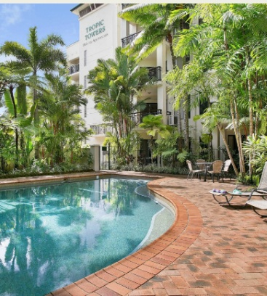
Situated close to the centre of Cairns and the table tennis centre, Tropic Towers is the ideal base accommodation when attending the Cairns Open Championships.

Tropic Towers offers a selection of spacious and comfortable 1 and 2 bedroom Cairns holiday apartments, each with a full kitchen, internet access and a private balcony for making the most of the renowned local climate.

Unwind by the pool in the lush tropical setting, sink into the spa, or enjoy a leisurely walk to the Esplanade to explore a wide range of cafes, bars and restaurants by the waterfront. With friendly onsite management, local transport links nearby and the Great Barrier Reef, Kuranda Rainforest and Daintree Rainforest right at your fingertips, Tropic Towers is ideal base for the Cairns Open Championships or a getaway to remember.

EVENT TIMETABLE (DRAFT)
Cannot enter
Time | Saturday, 19 September 2026
8:30 am | O70 Singles | U13 Singles
9:30 am | O50 Singles
10:30 am |  | U11 Singles | U21 Singles
11:00 am | O80 Singles
11:30 am | O65 Singles
12:00 pm |  | U15 Singles
1:00 pm | O40 Singles
2:00 pm |  | U19 Singles
2:30 pm | O75 Singles
3:00 pm | O60 Singles
4:00 pm | O30 Singles | U17 Singles
5:45 pm | Men’s Open Singles Groups  Women’s Open Singles Groups  (staggered start time up to 6:45 pm) | U1100 Doubles
7:15 pm | Open Singles Knock Out Finals | U1100 Singles
Approximate finish time: 9:30 pm
Time | Sunday, 20 September 2026
8:00 am | U1500 Singles | U900 Doubles Cannot enter both U1500
9:00 am |  | U900 Singles and under 900 events
10:00 am | U1500 Doubles
11:00 am | Mixed Open Doubles | U1300 Singles
1:00 pm | Men’s Open Doubles | Women’s Open Doubles
1:45 pm |  | U1300 Doubles
Approximate finish time: 3:00 pm
This is a draft timetable only. The final timetable will be completed after entries close and will be emailed to all participants

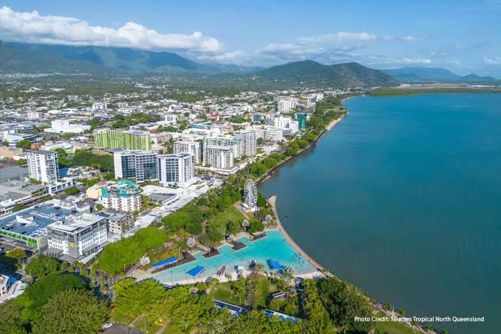






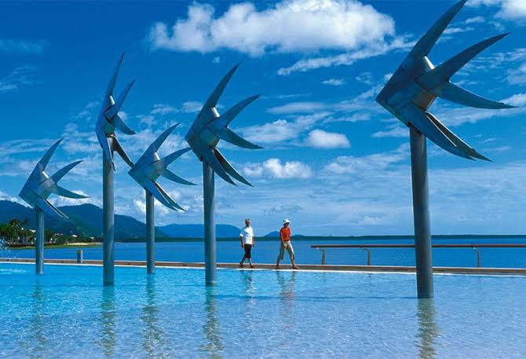
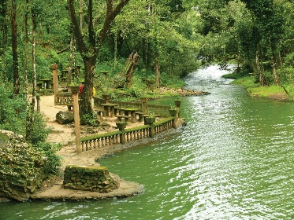
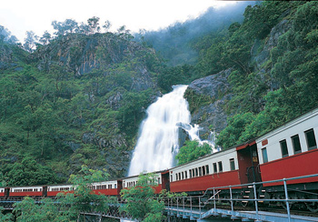

EVENT CONDITIONS
- Defined Terms: In these Event Conditions:
“TTC” means Table Tennis Cairns Inc Inc and where the context permits, includes its respective administrators, directors, agents, officers, officials, committee members, volunteers, employees, other participants, and any sponsors.
“you” or “your” means the member named in the Entry Form and wherever relevant, includes such members minor child, personal representatives, assigns, heirs, and next of kin.
- Tournament Control: The tournament will be held under ITTF rules & regulations.
- Match Control: Each match will be controlled by an umpire whose decision will be final on point of fact. The decision of the referee or deputy referee will be final on point of law.
- Affiliation: You must be a full registered member of an association affiliated with TTQ, TTA or ITTF.
- Fees: All entry fees must be paid before competing in any event in the tournament.
- Single Events: All single events will be played in round robin format in groups of 3 subject to change by the referee. 1 player will advance from the single event groups for all rated events. 2 players will advance from the single event groups for all aged events (subject to change by the referee).
- Event Format (Singles): Events 1 & 2 may subject to the referee’s decision be best of seven games at knockout stage (SF). All other events will be best of 5 games or 3 games, depending on the event.
- Doubles Events Format: All double events will be knock-out events.
- Doubles Partner: You must ensure that your doubles partners have submitted a separate Entry Form. If a partner is required, show ‘required’ in the space provided.
- Age limits: All junior events as at 1st January 2026 & veterans must be of age on 31 December 2026
- Age Events: Players may enter aged specified on the front page (subject to Referee discretion).
- Balls: ITTF approved 3-star white plastic balls will be used.
- Entries: Entry fee must be paid upon arrival at the centre and before the tournament commences. TTC may issue a tax invoice to players for payment in advance of the tournament. Late entries may be accepted at the discretion of TTC.
- Exclusion: The TTC committee reserves the right to refuse you entry in any event.
- Umpires: Losing players to umpire: No player may leave the centre before umpiring without approval of the referee.
- Game Readiness: Players not available when called for an event may be disqualified. All players must be ready to play at least 20 minutes prior to the scheduled start time. Matches may be called up to 20 minutes prior to the scheduled start time.
- Ratings Central: Ratings Central as at the time of entry closure will be used for all events.
- Social Media: You agree to any photos or video taken during the tournament to be used by TTC for advertising and promotional purposes, including on any form of social media.
- Event Cancellation: TTC reserves the right to cancel or combine events in which insufficient entries have been received.
- Seeding of Events: Seeding for all events (and acceptance of any unrated nominations) is at the discretion of the referee.
- Participating at Own Risk: You understand the nature of table tennis activities and are aware that participating in this sport contains risks. These risks may be caused by you and/or your minor child's own actions or inaction, or the actions or inaction of others. There may also be other risks and social and economic losses either not known to you or not readily foreseeable and you fully accept and assume all such risks and all responsibility for losses, costs and damages you incur as a result of your participation in the sport and this tournament. In consideration of TTC’s acceptance of your nomination to participate in this tournament, you willingly assume all risks including, but not limited to, falls, contact with other members, injuries and illnesses. You further waive and release TTC from all claims (including future claims), demands, losses, damages and liabilities of any kind known or unknown, arising out of your use of and participation in the sport and this tournament and the facilities contained in the TTC premises.
- Prize Money: Men’s Open Singles and Women’s Open Singles prize money will be $300 for the winner, $150 for the runner-up. This is subject to a minimum of 18 entries per event. The prize money for rated events and doubles events will be based on the number of entries. No prize money for losing semi-finalists.

